Task 2.3: Descriptive Analytics – KPIs

As key performance indicators for the bike sharing business of Bluebikes the average duration of usage, the shares of customers’ and subscribers’ related rides, the estimated revenue as well as average utilization rate.

The average duration of usage is depicted in the figure below. A rented bike was used for almost 19 minutes (18.91 minutes ≙ 1,134.89 seconds) on average per trip over the year 2017. On a monthly basis, the average duration of usage was 17.51 minutes with changes during the year. In general, from April to October the average usage was higher than the monthly average. Especially between April and June it was noticeably higher (> 20 minutes). The highest value was reached in April 2017 with 24.46 minutes, while the lowest average usage duration was recorded in February 2017 with only 11.36 minutes.

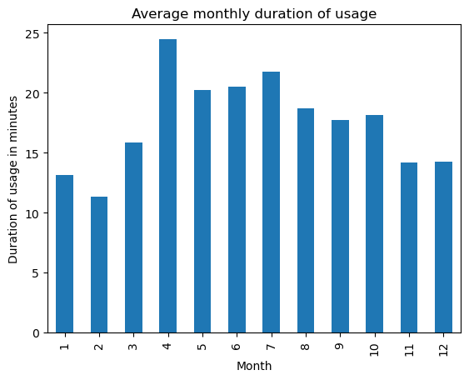  
Figure : Average Monthly Utilization

Another KPI contains the ratios of the different user types. For this, the shares of customers and subscribers are calculated. Although customers probably spend more money per minute due to the higher costs of single trips, the subscribers are important because they are the source of a steady monthly revenue stream. In 2017, there were 84.1% of the rides related to subscribers, whereas, in turn, only 15.9% were related to customers. The shares change from month to month. In particular, the highest percentage of subscribers related rides was recorded in December (96.40%), while the lowest percentage was in July (77.07%). The following figure depicts the distribution of the rides with respect to the two different user types in absolute numbers as well as in percentage. Looking at it, one can find that during the time from April to October the percentage rates of customer related rides is significantly higher than during the rest of the months. The simple conclusion behind this is probably that the subscribers are e.g., people commuting and also ride during the winter. The single trip users seem to prefer higher temperatures to use a bike from time to time.

Figure : Development of the monthly user types’ shares

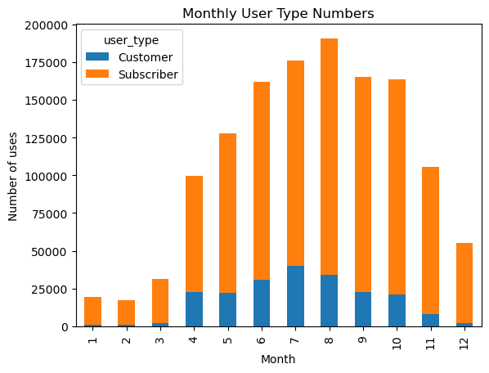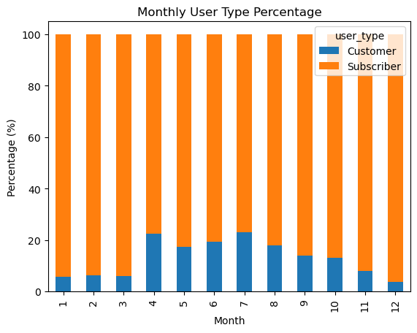

The revenue estimates is based on two components: The ride related revenues on the one hand and the monthly fee paid by subscribers on the other hand. For calculating the revenues resulting from the rides there were several conditions to consider. Subscribers have an unlimited contingent of 45-minute rides. They only have to pay for rides longer than 45 minutes, which amounts to $2.5 per additional 30 minutes. Customers instead pay per ride with rides up to 30 minutes for $2.95. Above that they are charged with an extra $4 per additional 30 minutes. Based on these conditions, the duration of each ride was checked in consideration of the respective user type associated with the ride. If the duration in fact was higher than 45 or 30 minutes for subscribers or customers the extra fees were calculated for this time. After adding the fixed fees for a customers’ rides and the monthly subscription fees, the highest revenue could be recorded for July 2017 with $501,199. The lowest revenue was in February ($198,479). This is probably due to the fact that according to Bluebikes’ website the season only opened on 27th February (https://www.bluebikes.com/system-data). However, there are still several rides recorded between the 1st January and the end of February. The figure below shows the total monthly revenues. In the appendix there can be found a list with the exact revenue divided according to the user types.

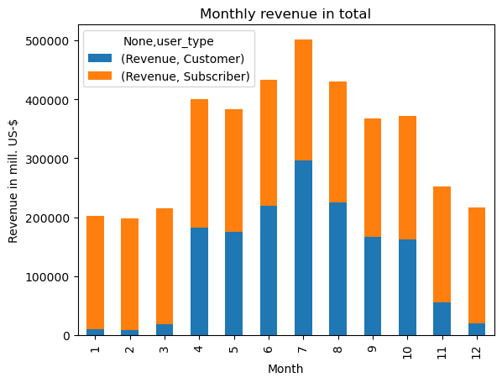  
Figure : Total monthly revenue

Finally, the utilization rate was computed as the last KPI. The highest rate was recorded on the 5th July when 71.25% of the bikes where used at least one during that day. In contrast to this, on the 13th February only 1.84% were used, but the season opening times have to be kept in mind at this point. The following graph shows the percentage of bikes which was used during a day at least one. Note that the rate of bikes used is quite high between April and September and the peaks during this time are above 60%, even heading towards 70%.

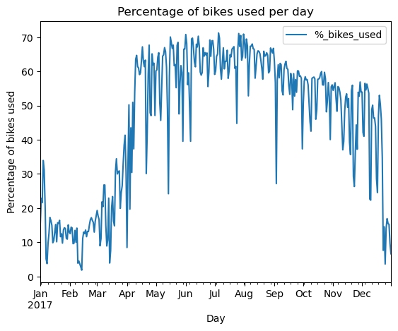  
Figure : Percentage of bikes used at least once a day

For the appendix:

